
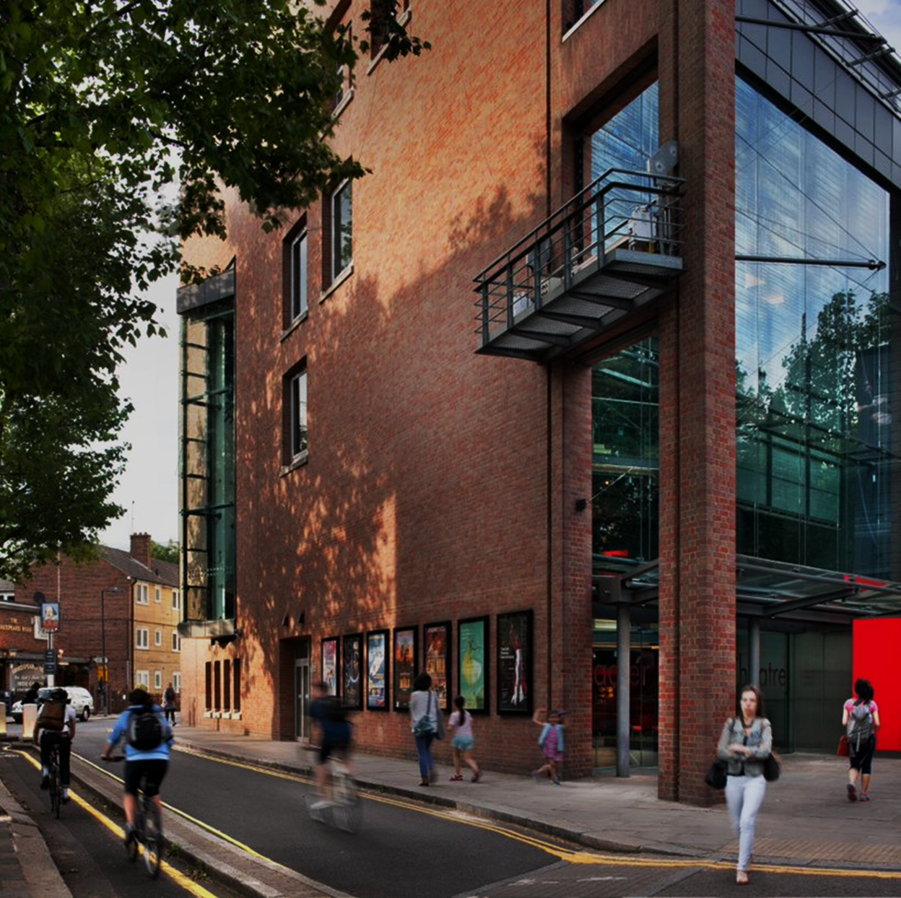

Sadler’s Wells
Major Gifts Manager

Contents

About us 3
Our Values 4
The Department 5
The Role 6
What are my responsibilities? 6
Who should apply? 8
Why work for us? 9

About us

Sadler’s Wells is a world-leading creative organisation, dedicated to presenting, producing and touring dance made today in all its forms. Sadler’s Wells commissions, presents and produces more dance than any other theatre in the world – from tango to hip hop, ballet to flamenco, Bollywood to cutting-edge contemporary dance. With an innovative, year-round programme of performances and learning activities, this is the place where artists come together to create dance, and where we welcome everyone to experience dance and be inspired.

Our aim is to reflect and respond to the world through dance: enabling artists of all backgrounds to create dance that moves us and opens our minds; sharing those experiences with the widest possible audiences to enrich their lives and deepen their understanding of what it means to be human.

More than half a million people come to our theatres in London each year, with many more enjoying our touring productions at partner venues across the UK and in cities around the world. Sadler’s Wells Theatre has been located in Islington since the 17th century. Today Sadler’s Wells consists of the Sadler’s Wells Theatre (1,500 seats); the Lilian Baylis Studio (180 seats); three rehearsal studios; bars, a café, facilities for private and corporate entertaining and offices for Sadler’s Wells’ colleagues.

Our second theatre building and West End home, the Peacock (1,000 seats), is subject to a unique agreement whereby Sadler’s Wells and the London School of Economics jointly manage it, with the LSE presenting its lectures to students during the day and Sadler’s Wells presenting theatre at night.

Our fourth venue Sadler's Wells East opened this year in east London’s Queen Elizabeth Olympic Park. Sadler’s Wells’ new space is located on the Stratford Waterfront site, opposite the London Aquatics Centre, alongside UAL’s London College of Fashion and the V&A Museum. The site forms part of a new cultural and education district, which will also include a major new University College London (UCL) campus with direct links to the creative communities already based in east London.
Sadler’s Wells’ new space houses a 550-seat mid-scale theatre, as well as facilities for the Rose Choreographic School and Academy Breakin' Convention.

Our Values

COLLABORATION
 | - We are encouraging and supportive  - We work as one team  - We listen  - We seek and value diversity of thought and practice  - We pool our knowledge, resources and creativity  - We create opportunities to work in partnership and minimise silos
EXCELLENCE
 | - We are ambitious and driven  - We make and share meaningful, exciting and impactful dance  - We are the best we can be each day, going above and beyond in our own way  - We continuously learn and develop our skills  - We operate sustainably by maximising our resources  - We hold each other accountable
INCLUSION
 | - We are brave and kind  - We create a safe place so colleagues can bring their full selves to work  - We celebrate our differences  - We remove barriers to access or equality  - We are actively anti-racist and address all forms of discrimination  - We engage and reflect the diverse community we are part of
INNOVATION
 | - We are curious and bold  - We find a better way in the everyday  - We challenge and question, asking ‘why?’ and ‘why not?’  - We take creative and calculated risks  - We try new things and embrace change  - We learn and grow from our mistakes

The Department

The Development Department currently raises £3.5 million a year in private support from patrons and major donors, corporate sponsors and trusts and foundations. We are building on this success and have ambitious targets in the years ahead.
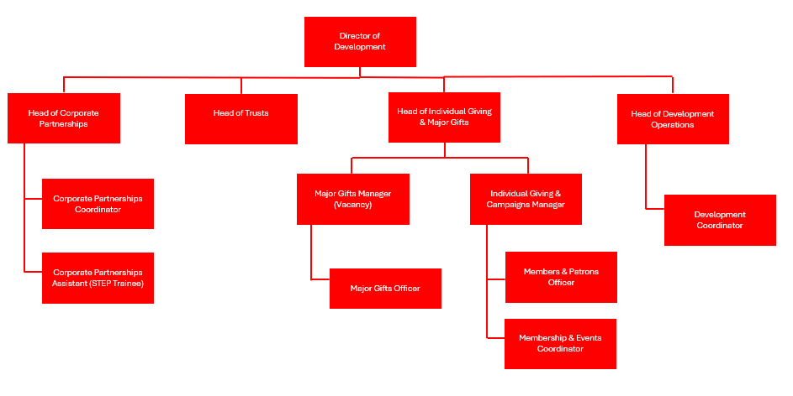

The Role
The Major Gifts Manager will work closely with the Head of Individual Giving & Major Gifts to provide support on all gifts at £12,000 and above.
The role combines face-to-face fundraising of the annual Major Donor levels of Artistic Director’s Circle and Avant Guardians, implementing the strategy to recruit further support at these levels as well as supporting recruitment at the Major Project Support level which begins at £50,000. There is regular and proactive collaboration with development department colleagues and the wider Sadler’s Wells team to deliver a dynamic programme of donor cultivation and stewardship.

What are my responsibilities?

Fundraising
- Manage the annual Major Gifts programme (Avant-Guardians and Artistic Director’s Circle), overseeing stewardship, retention and recruitment as well as the implementation of the five-year fundraising strategy of this income area.

- Develop and maintain excellent relationships with own portfolio of major donors as the ‘Primary Worker’

- Work with the Head of Individual Giving & Major Gifts to deliver special fundraising events for cultivating and stewarding Major Project Supporters and annual Major Gifts Supporters.

- Work with the Head of Individual Giving & Major Gifts to identify and cultivate Major Project Supporter prospects from current Sadler’s Wells donors.

- Support on administration of Major Project Support, including writing reports, gift agreements and stewardship touchpoints with donors.

- Along with other team members, support administration of Sadler’s Wells America, our 501 (c)(3) US entity.

- Build strong relationships with other departments and project teams to foster a deep understanding of, fluency with, and confidence in talking about the work and vision of Sadler’s Wells and related disciplines.

- Recognise and exploit key crossovers exist between all income areas (e.g. Individual Giving/Corporate Giving/Sponsorship/Trusts and Foundations) and liaise with colleagues as appropriate to ensure best results.

- Attend regular Development evening events as necessary.

- Network and gain knowledge across the fundraising spectrum.

Management and Administration

- Line Management and development of the Major Gifts Officer including carrying out annual reviews and objective setting.

- Ensure the team maintain accurate financial records and cultivation and stewardship plans.

- Ensure compliance with GDPR and other relevant legislation and regulations.

- Keep abreast of developments in fundraising best practice, new funding programmes and legislation and contribute to any changes in procedures and practices as appropriate.

- Represent Sadler’s Wells at external meetings and events.

General
- Live, breathe and role model our organisational values of Excellence, Collaboration, Inclusion and Innovation, being aware of the influence and impact you can have in Sadler’s Wells

- Attend occasional staff meetings, training sessions and other events which may take place outside normal working hours
- Undertake other duties as may be reasonably required

- At all times to carry out duties and responsibilities with regard to Sadler’s Wells’ Equality, Diversity and Inclusion and Health and Safety Policies. This may include providing assistance with evacuation procedures or building searches in the event of an emergency at any of Sadler's Wells’ premise

THIS JOB DESCRIPTION IS A GUIDE TO THE NATURE OF THE WORK REQUIRED OF THIS POSITION. IT IS NEITHER WHOLLY COMPREHENSIVE NOR RESTRICTIVE AND DOES NOT FORM PART OF THE CONTRACT OF EMPLOYMENT.

Who should apply?

The successful applicant will demonstrate the following skills, experience, and personal qualities.

Essential

Experience and knowledge

- A proven track record in achieving fundraising targets from major donors at the £25,000 and above level

- A personal track record in initiating and securing new gifts and retaining support from individuals

- Experience of creating and developing strong relationships with supporters and stakeholders at all levels

- The ability to work both as part of a team, and autonomously

- Experience of managing expenditure and income budgets and in communicating and presenting financial information

- Thorough knowledge of fundraising database systems

- Experience of Line Management and supporting others within their role/s, with positive performance management

Skills and abilities

- Ability to think strategically and creatively and contribute effectively to department strategy

- Ability to work effectively under pressure and to meet challenging targets, multi-tasking and delegating where needed

- Excellent written and oral communications skills with keen attention to detail

- Excellent IT skills; including spreadsheets and presentation packages

- Proactive, entrepreneurial and creative in identifying new income sources

- Diplomatic, with a professional approach to good customer care

- Ambitious, collaborative and enthusiastic

- Available to work in the evenings on a regular basis

- Demonstrable interest in the performing arts
- Must currently hold the right to work in the United Kingdom
Additional, but not essential
- Experience of working within an arts organisation / charity

- Demonstrable working knowledge of Sadler’s Wells work and activities

- Experience of using Tessitura

- Experience/knowledge of contemporary dance and/or theatre

If you don’t have everything listed here, but believe you have demonstrable experience to take into consideration, please apply. We are aware every applicant will have strengths and development areas to accommodate, and we are open to discussions around how we can support the postholder.

Why work for us?
Salary: £41,855.56 per annum
Hours of work: Full-time, 40 hours per week
Start date: from February 2026
You will be a key part of our mission to make and share dance that inspires us all and delivering our vision to create, through dance, a depth of connection beyond borders, cultures and languages, so we see ourselves in each other.
- You will get 25 days annual leave per annum (pro rata), with an additional 3 days after five years’ service
- You will be enrolled into the Sadler’s Wells Trust Ltd. pension scheme
- You will have access to our Employee Assistance Programme (EAP) to support your wellbeing
- Engage in learning and project opportunities to develop personally and professionally, and support your career journey
- You can access an interest-free Season Ticket Loan and a Cycle to Work salary sacrifice scheme
- You will be eligible for a death in service insurance policy covering twice your annual salary
- You will be encouraged to attend performances at both theatres with a discretionary allocation of tickets to employees (subject to availability), and a staff discount at the Garden Court Café
- We welcome everyone through our doors and encourage and enable people to be the best versions of themselves and to feel confident and capable in their roles
- We celebrate diversity in the dance we share and showcase, and in our workplace. We are working hard to be more inclusive and increasing access both on stage and off and have several anti-racism commitments to make lasting changes in the way we work

Making an application
A Job Description and Person Specification are included in this document. If after reading you are still interested in applying, please find further details and information on how to apply Valued Recruitment link. If you would like support or have any queries regarding the format or submission of the application, please contact us by emailing Valued Recruitment link.
Sadler’s Wells welcomes applications from people from all backgrounds, who feel they align with our mission, vision and values. It is important to us that representation continues within our team and we encourage applications from people from global majority ethnic minorities. We are proud to be a Disability Confident employer, meaning we have been certified by the government as actively taking steps to attract,

recruit and retain disabled workers. We understand that some disabled colleagues will need adjustments to help them perform to the best of their ability – these can be changes to the built environment and furniture, the tools and technology they use in doing their job, aspects of the role, ongoing support or working arrangements. Sadler’s Wells is a PiPA (Parents and Carers in Performing Arts) Charter Partner, striving towards creating a more family friendly working environment.
We welcome all applications by 11:59 PM BST on Monday 26 January 2026. First round interviews will take place virtually, Thursday 29 January.

