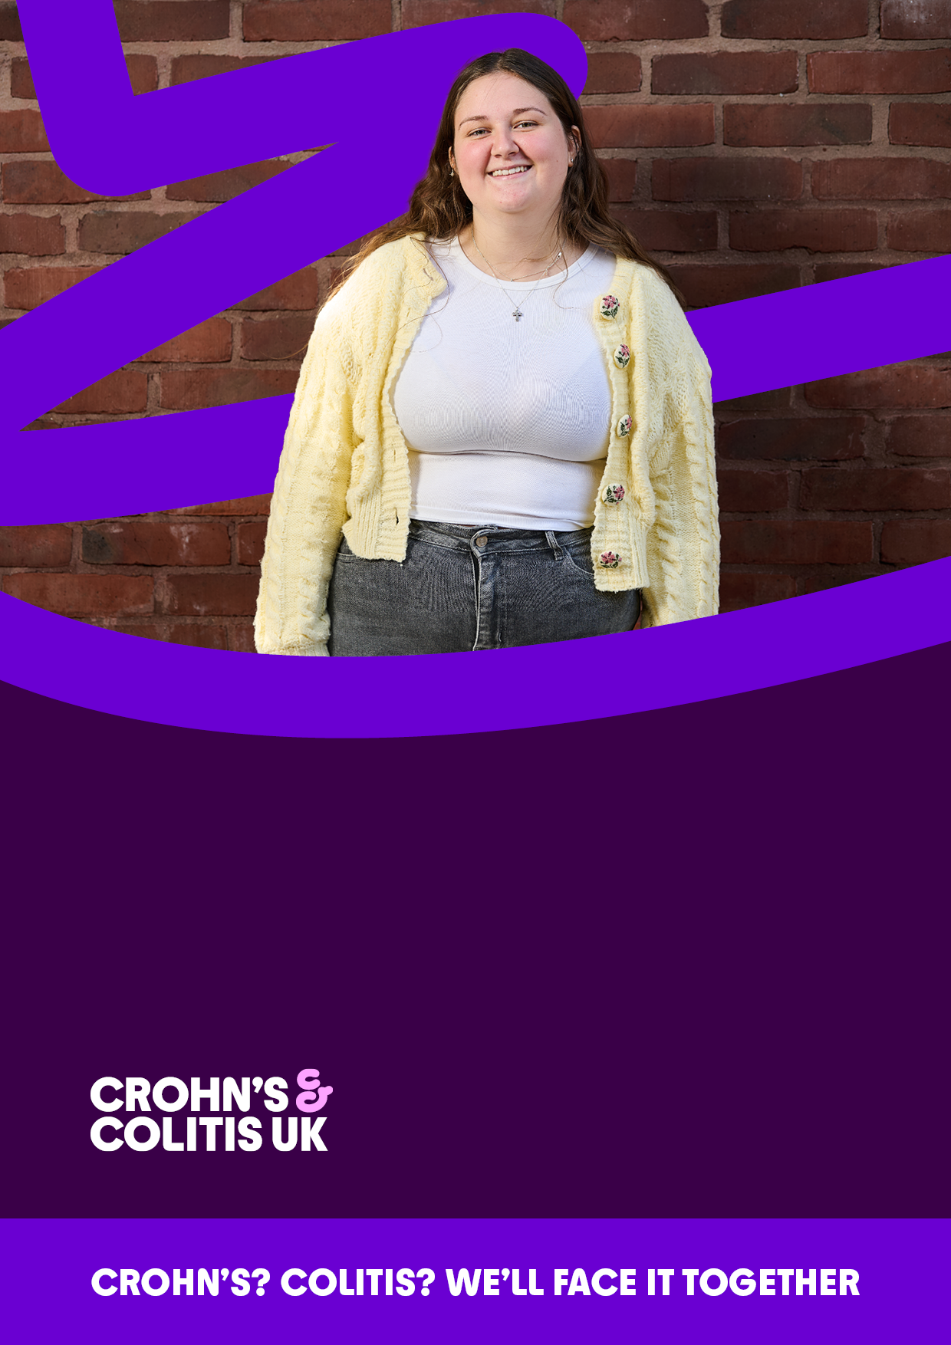

YOUNG ADULTS ADVISORY PANEL

Recruitment Pack, April 2026

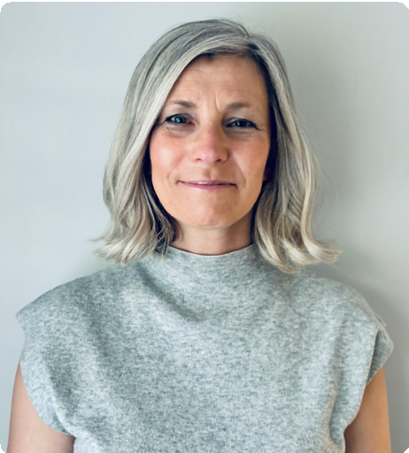

HELLO,
I’m so pleased you’re considering applying for this role at Crohn’s & Colitis UK. It’s an exciting time to join the charity and a brilliant opportunity to make a positive difference for our thriving community.

There are currently more than half a million people in the UK living with these conditions: that’s around
one in every
120. Your family, my friends, our
colleagues, struggling to navigate life with an unpredictable condition that could flare up at any time.
One of the major challenges is that, to others, Crohn’s and Colitis can seem invisible. But the pain is real, the fatigue debilitating, and the spectre of having to rush to the toilet, urgently and frequently, looms large.
Yet, to the outside world, many patients might appear to be in perfectly good health. As one person I met recently put it: “I look fine, but internally, a war is raging every day.”
There is currently no cure for Crohn’s or Colitis. People are waiting too long to be diagnosed and to access treatment. The NHS is under resourced and under pressure. It’s time for change. People with Crohn’s and Colitis deserve more.
That’s why we’ve developed and launched a bold new strategy. It’s our ten-year ambition to transform the world for everyone affected by Crohn’s and Colitis. It’s our blueprint to increase understanding of the conditions, so that people are diagnosed quickly and live well.
And it contains our ambitious plan to unite our community - researchers, patients and healthcare professionals, here and around the world - to set out the roadmap to a cure.
We’ve also transformed the way we communicate, with a fresh new look that’s impossible to ignore.
This is a bold, new vision for the future, with everyone affected by Crohn’s and Colitis at its heart. Amplifying their voices, reshaping how the world sees these conditions, fighting for a tomorrow where everyone living with Crohn’s or Colitis has everything they need to live well, and for a future where we don’t have to live with it at all.
Inspired? At Crohn’s & Colitis UK we offer an energetic, empowering working environment that’s rooted in our values. This pack should give you all the information you need to complete your application, and we look forward to hearing from you soon.
Crohn’s? Colitis? We’ll face it together.

Marianne Radcliffe, Chief Executive Officer Crohn’s & Colitis UK

WE’RE LOOKING FOR NEW MEMBERS OF THE YOUNG ADULTS ADVISORY PANEL

  - We are looking for enthusiastic young adults who want to help shape the work of the charity to meet the needs of all young adults living with Crohn’s and Colitis. You will join a strong, passionate and committed group of people on the Young Adults Advisory Panel, which provides strategic advice to the Board of Trustees on issues where a young adult’s voice is required.

WHO ARE THE BOARD OF TRUSTEES?
  - The Board of Trustees is an appointed or elected group of individuals that have overall responsibility for the management of the organisation. The Board is typically the governing body of an organisation and hold the Senior Leadership Team accountable for the organisation’s performance, strategy and policy. You can read more about them here:

THE ROLE
  - This volunteer role will be a dynamic role and will involve providing advice on various broad programmes of work undertaken by the charity and the development of strategic plans
  - Contributing actively to Panel meetings
  - Using any specific experience or knowledge to help the Panel reach sound decisions

WHO WE ARE LOOKING FOR
  - People aged 18 to around 28 years old, who either have Crohn’s or Colitis, or are closely connected to someone who has Crohn’s or Colitis
  - Ambitious individuals who are committed to the values and goals of Crohn’s & Colitis UK
  - A confident communicator and listener
  - Strong ability to share not only your views but represent other young adults’ views in the Crohn’s and Colitis Community Demonstrate behaviours in line with the Charity

DIVERSITY & INCLUSION AT CROHN’S & COLITIS UK
  - We are passionate about our work reflecting the diversity of the community we serve, and our young adult advisory panel should represent the demographics and identities of the UK.
  - To ensure a balanced representation of the UK, we particularly encourage applications from individuals who are from Scotland and Wales, as we do not currently have representatives of these nations on our young adults panel.
  - We offer equal opportunities to all, regardless of an individual’s age, disability, gender identity, marriage or civil partnership status, race, religion or belief, sex and sexual orientation.

WHAT WE CAN OFFER YOU
  - Support and training, as needed, to carry out the role successfully
  - Opportunity to develop your communication, listening and strategy skills
  - Gain valuable experience in how charities are organised and run
  - Develop new contacts as well as the knowledge that you are making a valuable contribution to the work of the charity.

ADDITIONAL INFORMATION
  - This is a one year role
  - Meetings will generally be held virtually, with at least one face to face meeting per year held in our Hatfield office, London or another city which is convenient for panel members.
  - There will be a minimum of two meetings per year and a maximum of six. Meetings are usually around 2 hours long. To prepare for meetings panel members will be required to review papers, this should take around 30 minutes per meeting.
  - Expenses for travel and any overnight stays will be covered in full

APPLICATION PROCESS
  - Valued Recruitment is working with Crohn’s & Colitis UK to recruit our new Young Adults Advisory Panel members. They are an ethical recruitment company, intent on hiring inclusively and transparently.
  - How to apply: Please send us an expression of interest in any of these forms:
    - Video
    - Audio
    - Written
  - We’d love to hear why you would like to be a member of the Panel and what you can bring to the role. Video and audio applications should be no more than a couple of minutes and written applications should be no more than a page.

  - Please email your interest to anna@valued-recruitment.co.uk and include your name and contact number. We look forward to hearing from you
  - Closing date: 5pm on Monday 11th May 2026
  - A shortlist will be created in W/C 11th of May, and successful candidates will be invited to a virtual interview with Paige Karadag (YAAP Chair) and Rosie Cook (Trustee) on either the 19th or 20th of May.
  - You will be asked if you would like any reasonable adjustments when invited to interview.
  - All interviewed candidates will receive feedback and outcome after the interview
  - Successful candidates will be appointed to the panel, effective 1st June 2026.

OUR STRATEGIC AMBITION 2026-36

THE FOUR PILLARS OF OUR STRATEGY
12
Unite researchers, patients and healthcare professionals to set out a roadmap to a cure.
22
Transform understanding of Crohn’s and Colitis.

Drive improvements in diagnosis, treatment and care.
32

4

Support people to live well.

A world without
Crohn’s and Colitis.

We inform, empower and unite our community so people living with Crohn’s and Colitis can lead better lives.

AMBITIOUS
COMPASSIONATE
STRONGER TOGETHER
OUR VALUES
OUR PURPOSE
OUR VISION


WE LOOK FORWARD TO RECEIVING YOUR APPLICATION
Join us and help fight for a tomorrow where everyone living with Crohn’s or Colitis has everything they need to live well, and for a future where we don’t have to live with it at all.
VISIT OUR WEBSITE
crohnsandcolitis.org.uk

LET’S GET SOCIAL
/crohnsandcolitisuk
@crohnscolitisuk
@crohnsandcolitisuk
@crohnscolitisuk

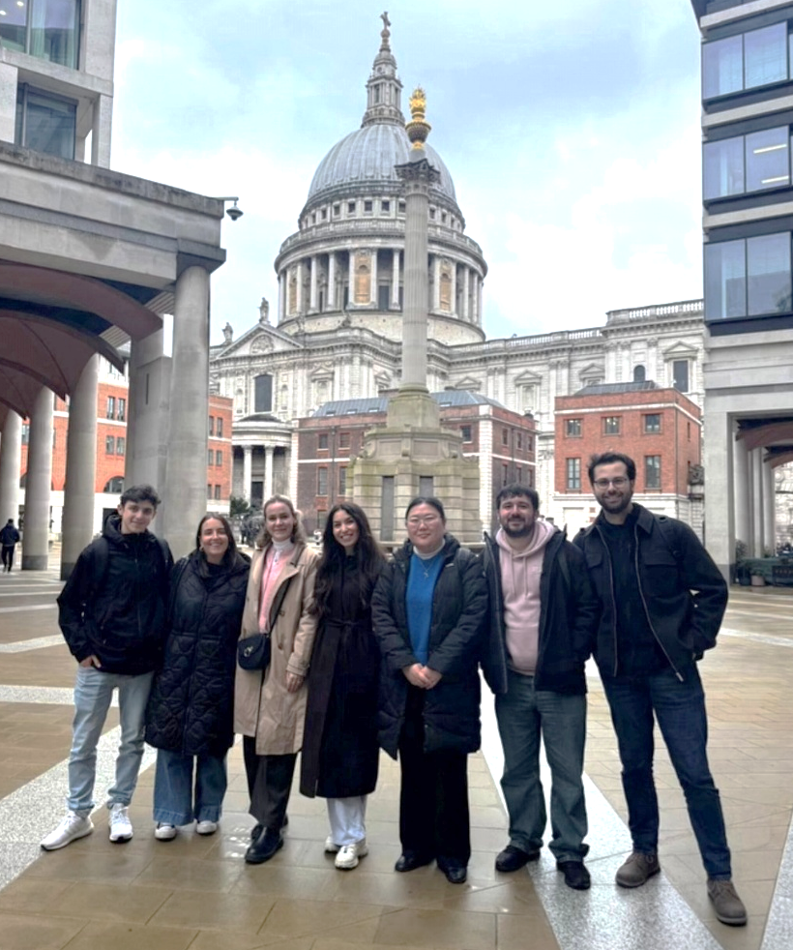

TOGETHER
OUR YAAP
MEMBERS

Registered as a company limited by guarantee in England & Wales (5973370). 1 Bishops Square, Hatfield, AL10 9NE
A charity registered in England. and Wales (1117148)
and Scotland (SC038632)

